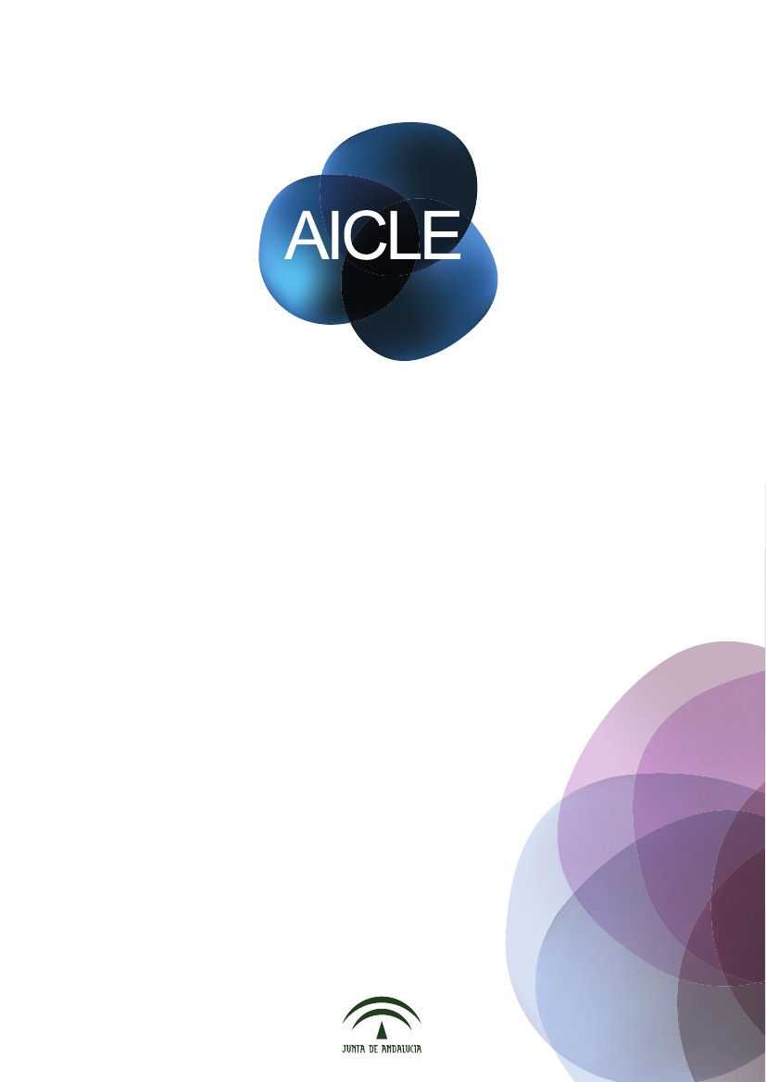
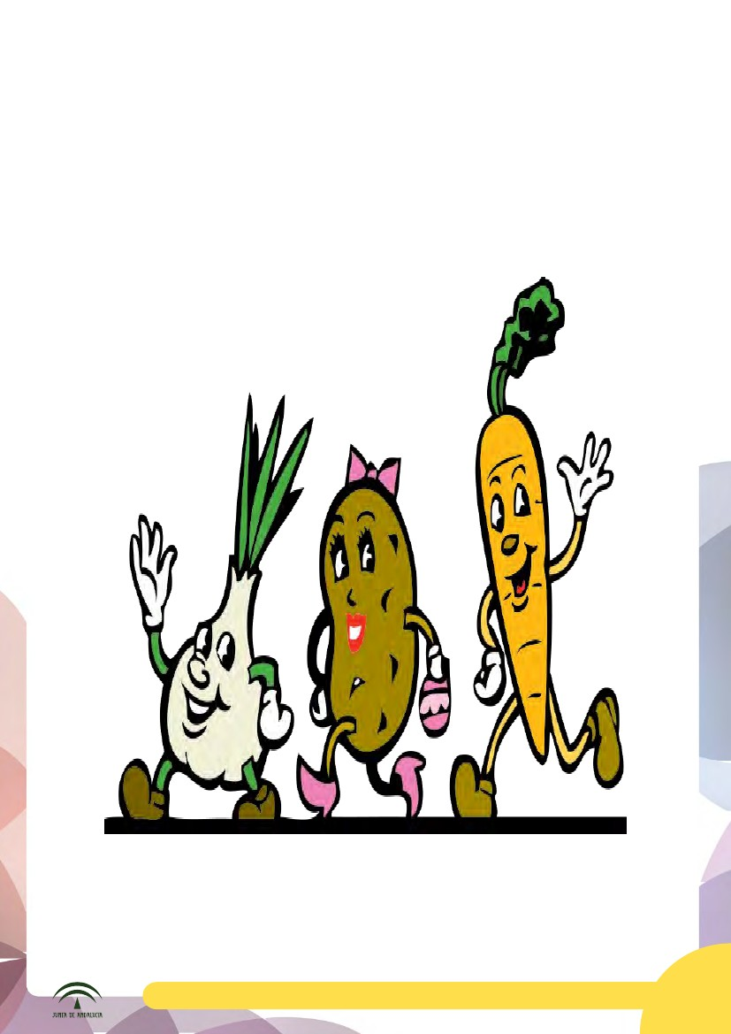
Food and Meals

Name: _____________________________________________
Material AICLE. 1º de Primaria: Food and Meals
5

1
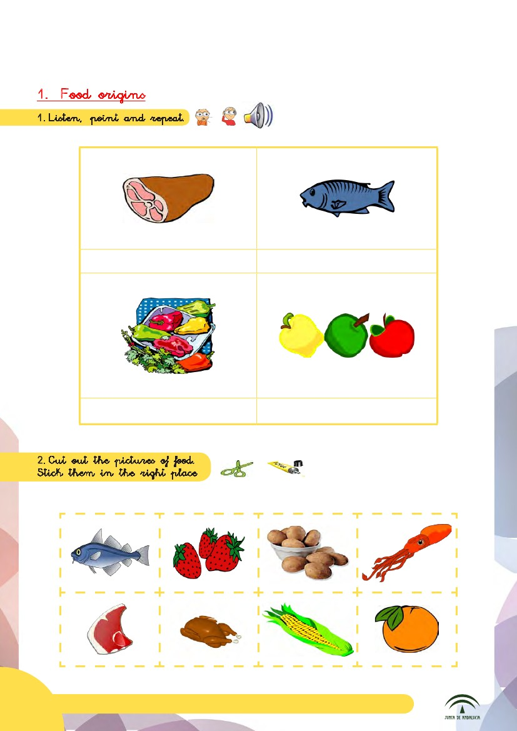
1
Meat
Fish
Vegetables

Fruit

6
Material AICLE. 1º de Primaria: Food and Meals
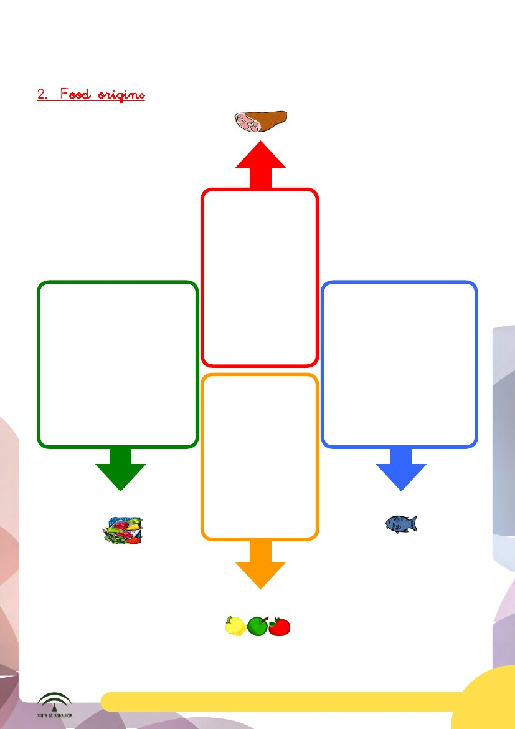
Meat

Vegetables

Fish

Fruit

Material AICLE. 1º de Primaria: Food and Meals
7
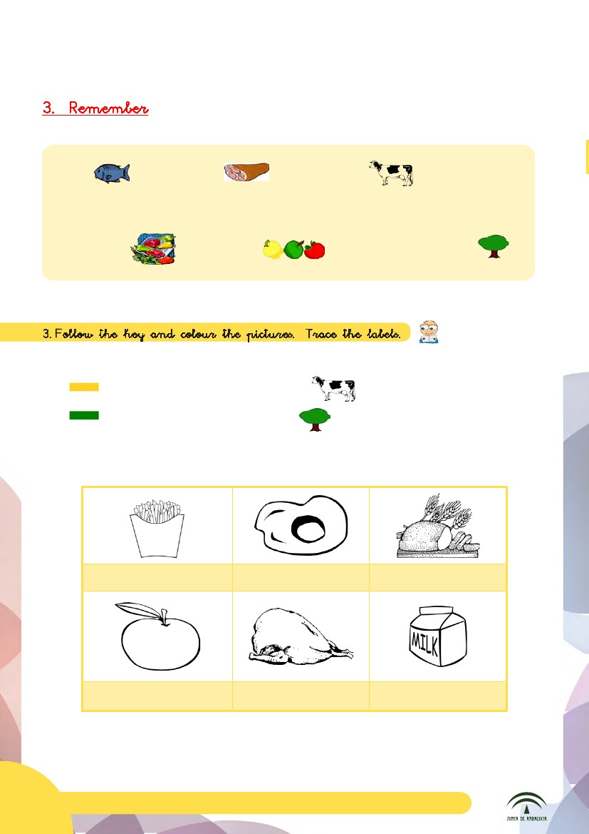

Fish
and meat
come from

animals.

Vegetables

and fruit

come from plants.
3

Food that comes from an animal.
Food that comes from a plant.

French fries
Egg
Bread
Apple
Chicken
Milk
8
Material AICLE. 1º de Primaria: Food and Meals
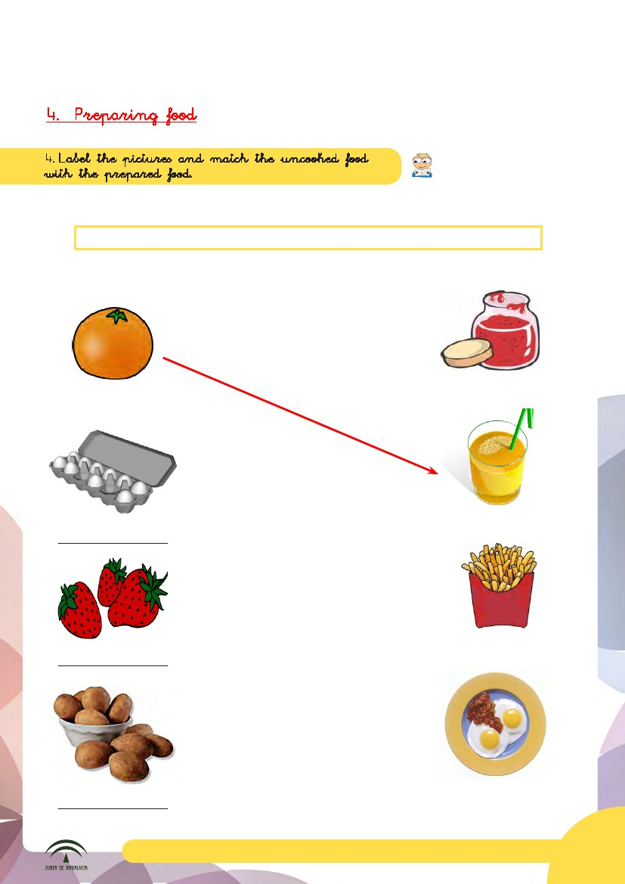
4
eggs
strawberries
potatoes
orange
Orange

Strawberry jam

orange juice

French fries

Material AICLE. 1º de Primaria: Food and Meals
Fried eggs

9
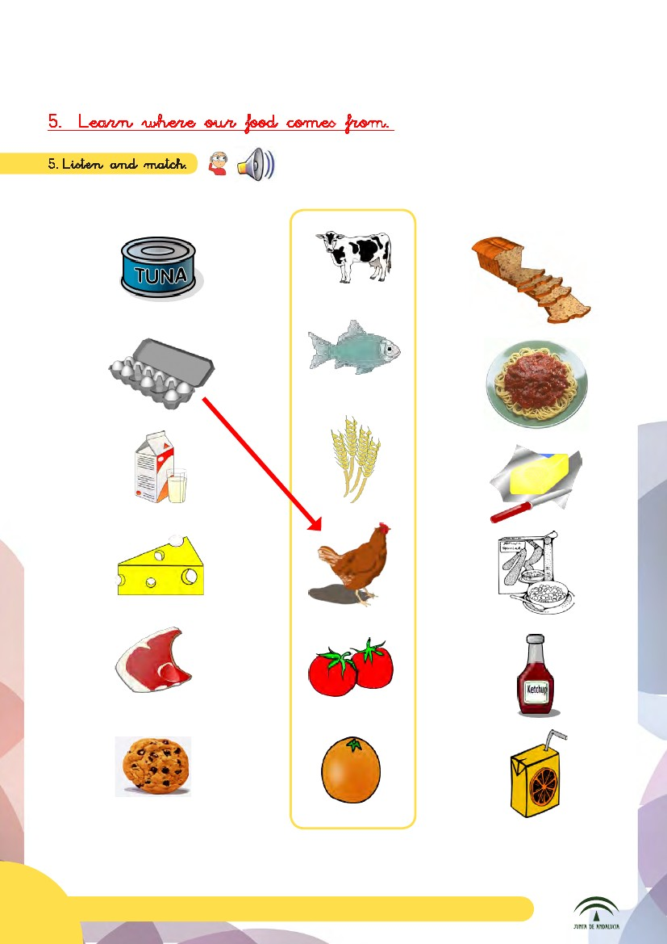

2

10
Material AICLE. 1º de Primaria: Food and Meals
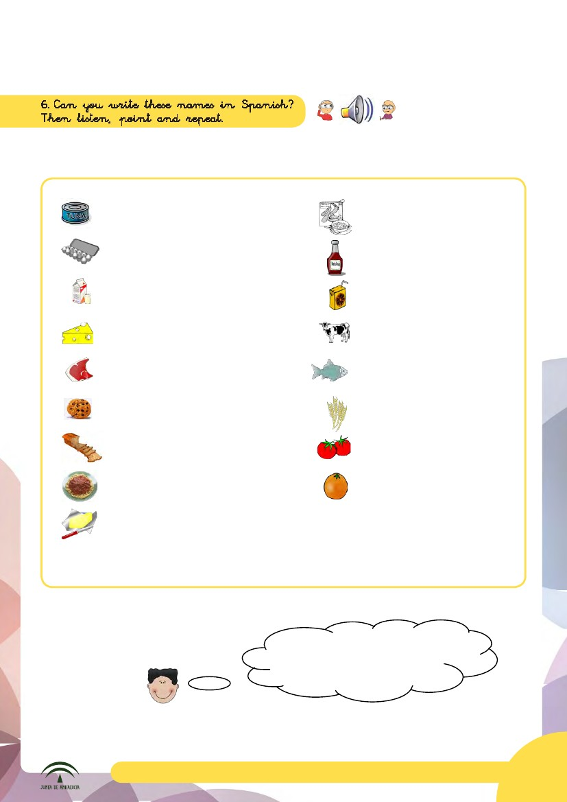
3

Tuna: Atún
Eggs: ..................
Milk: ..................

Cereal: ..................
Ketchup: .................
Juice: .................
Cow: .................
Fish: .................
Wheat: .................
Cheese: ................
Steak: ................
Cookie: ................
Bread: ................
Pasta: ................
Butter: ................

Tomatoes: .................
Orange: .................

Naranja, tomates, vaca, zumo,
kétchup, atún, pescado, trigo, pan,
filete, mantequilla, cereales, leche,
huevos, pan, galleta, pasta
Material AICLE. 1º de Primaria: Food and Meals
11
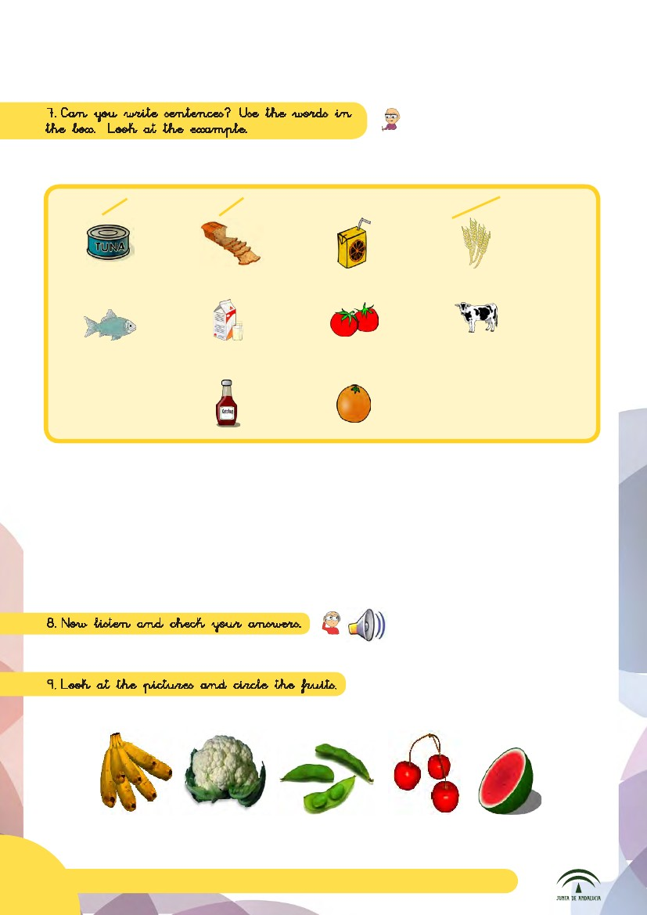

tuna

bread

orange juice

wheat

fish
milk

tomatoes

cows
ketchup

oranges

1. Bread comes from wheat.
2. Tuna
comes from ..........
3. .........comes from ..........
4. ............ comes from .........
5. .............................

4

12
Material AICLE. 1º de Primaria: Food and Meals
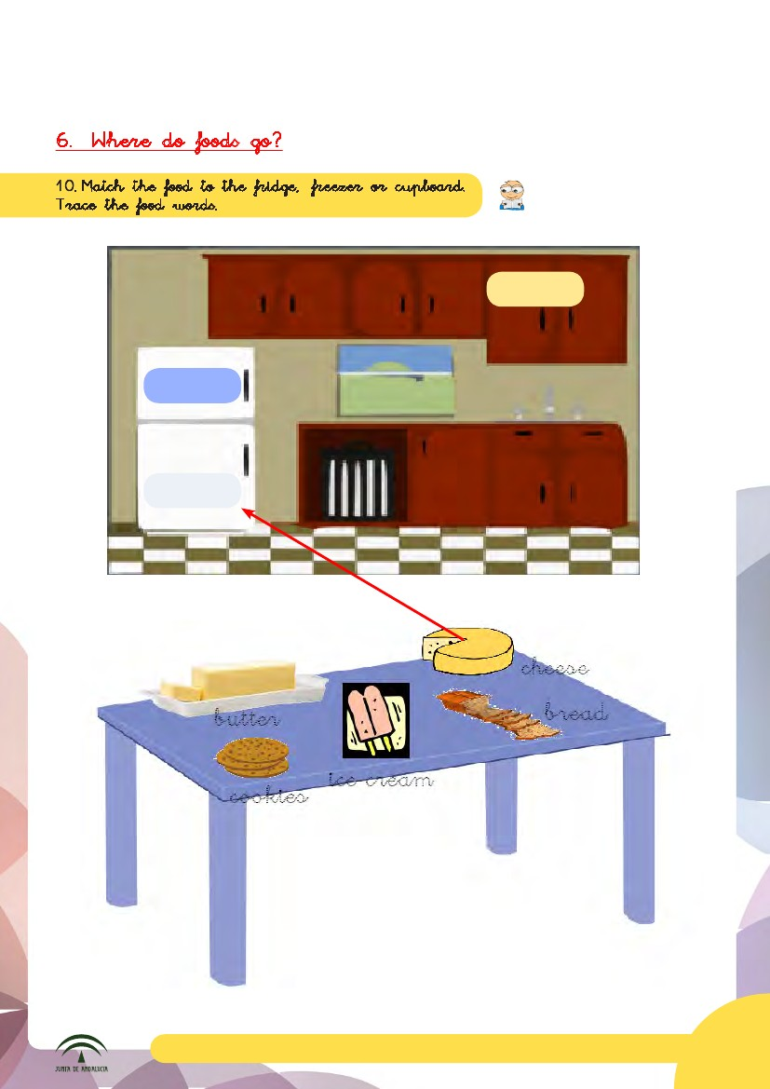
1
cupboard
freezer
frigde

Material AICLE. 1º de Primaria: Food and Meals
13
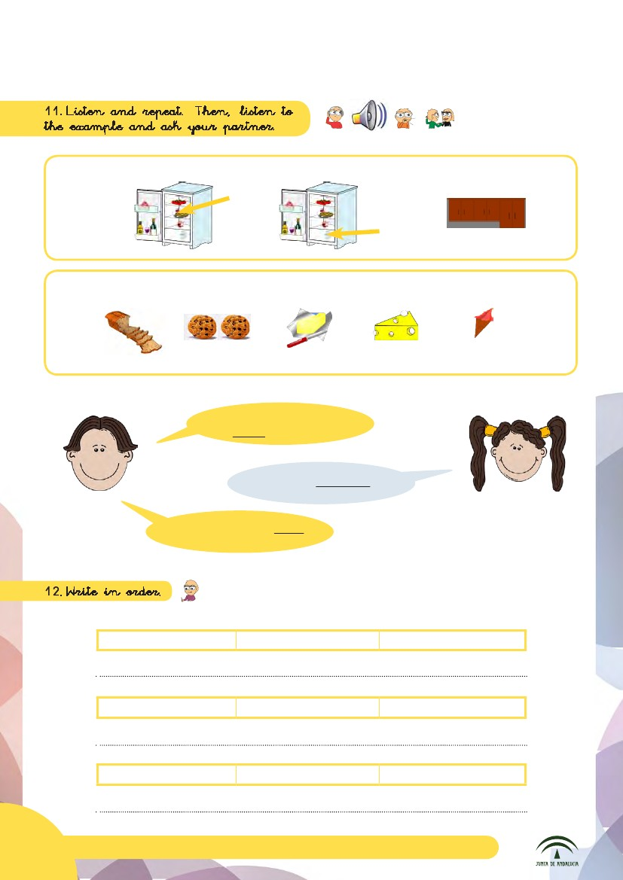
1
fridge

bread
cookies

5
freezer

butter

cupboard

cheese

ice cream

Where does the
bread go?

In the cupboard
Right ! Your turn!

comes from
Milk
animals
prepared food
is
Jam
in the freezer
Ice Cream
goes
14
Material AICLE. 1º de Primaria: Food and Meals
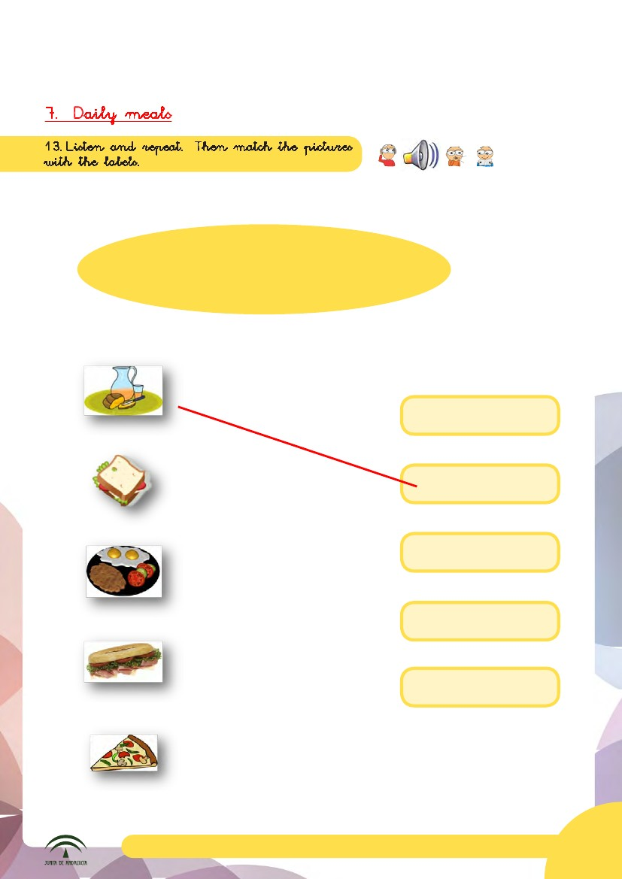
1
6
Breakfast
Dinner
Mid-morning break
Lunch
Tea time

Mid-morning break
Breakfast

Tea time

Lunch

Dinner

Material AICLE. 1º de Primaria: Food and Meals
15
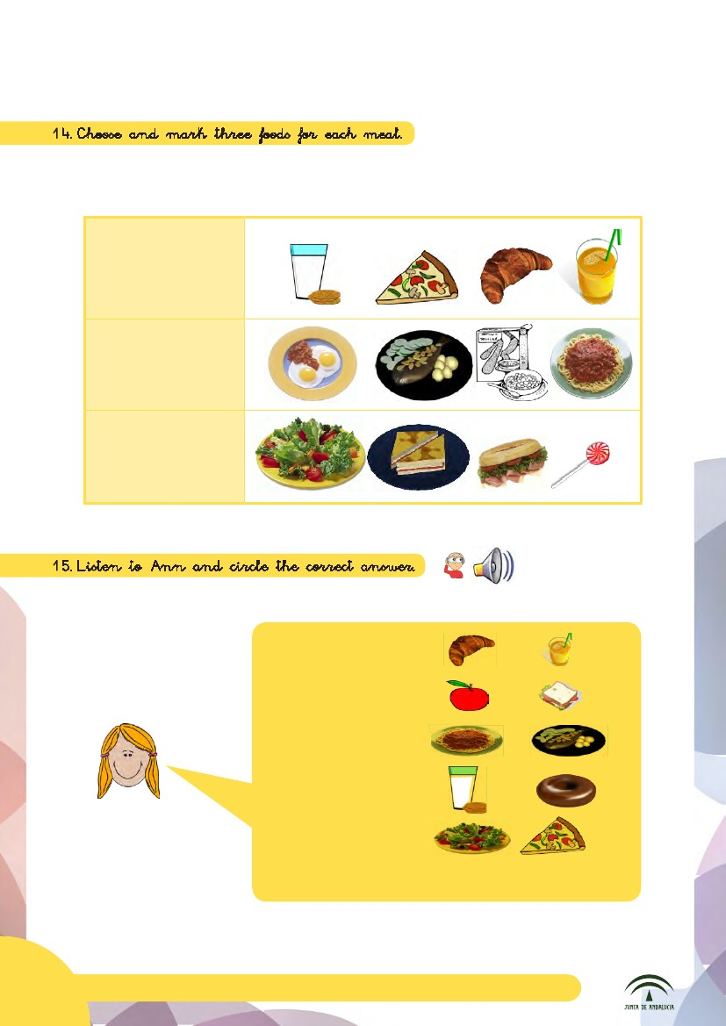
14.Choose and mark three foods for each meal.
Breakfast
Lunch

Dinner

15.Listen to Ann and circle the correct answer.
7
Breakfast
Mid-morning

Mid-morning break Mid-morning

breakMid-morning break

break
Mid-morning break
Mid-morning break

Tea timeTea time
Tea time
Tea time
Tea time
Tea timeTea time
DinnerDinner

DinnerDinner
Dinner
Dinner
Dinner

16
Material AICLE. 1º de Primaria: Food and Meals
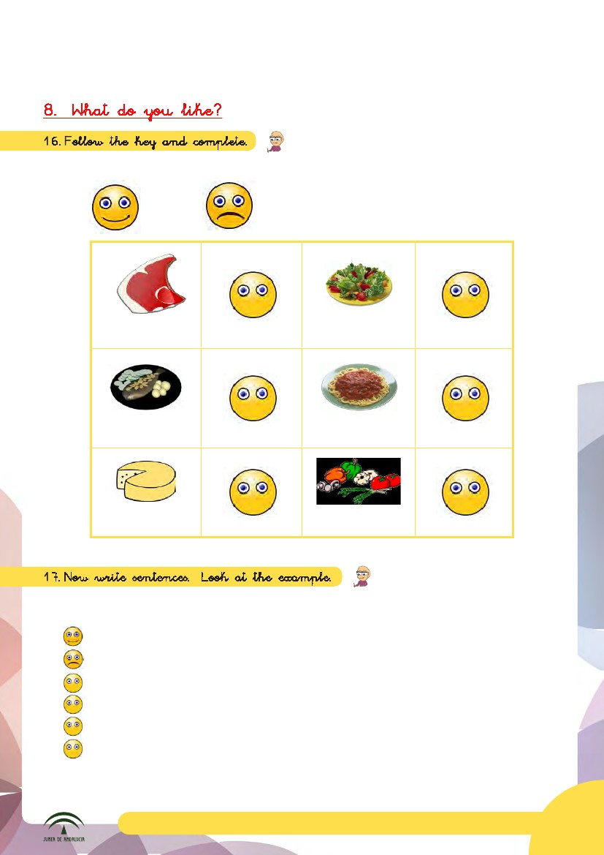
8. What do you like?
16.Follow the key and complete.

I like

I don´t like
Steak
Salad
Fish
Pasta
Cheese
Vegetables

17.Now write sentences. Look at the example.

I like pasta.
I don’t like cheese
I ................................
I ................................
I ................................
I ................................

Material AICLE. 1º de Primaria: Food and Meals
17
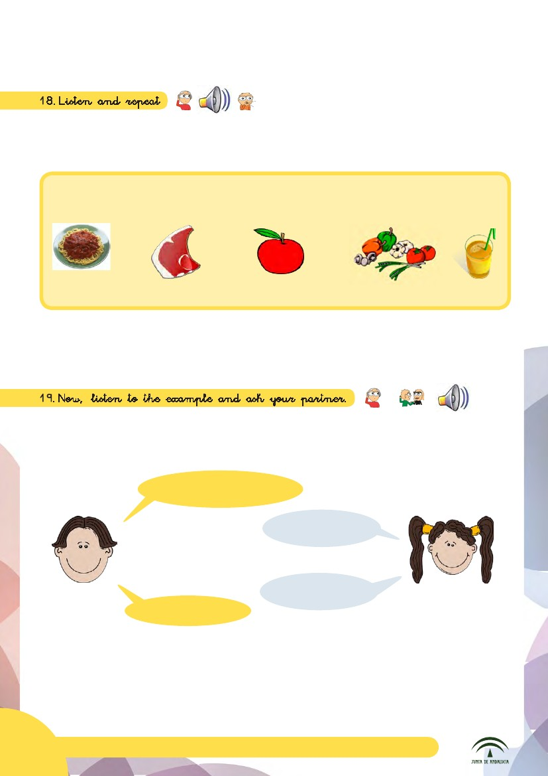

18.Listen and repeat.
8
19.Now, listen to the example and ask your partner.
Do you like fish?
Yes, I do

No, I don’t.
Do you like
salad?
18
Material AICLE. 1º de Primaria: Food and Meals
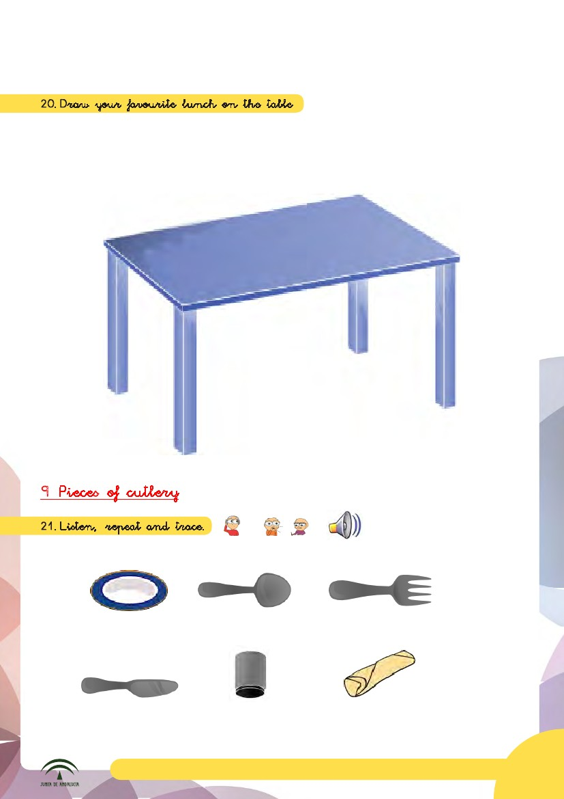
20.Draw your favourite lunch on the table.

9 Pieces of cutlery
21.Listen, repeat and trace.

Plate

Spoon

Fork

Knife
Glass
Napkin
Material AICLE. 1º de Primaria: Food and Meals
19
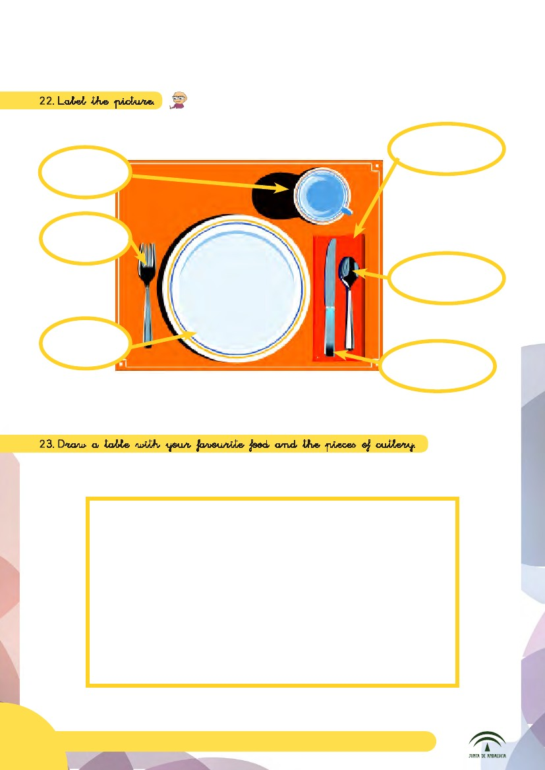
22.Label the picture.

23.Draw a table with your favourite food and the pieces of cutlery.
20
Material AICLE. 1º de Primaria: Food and Meals
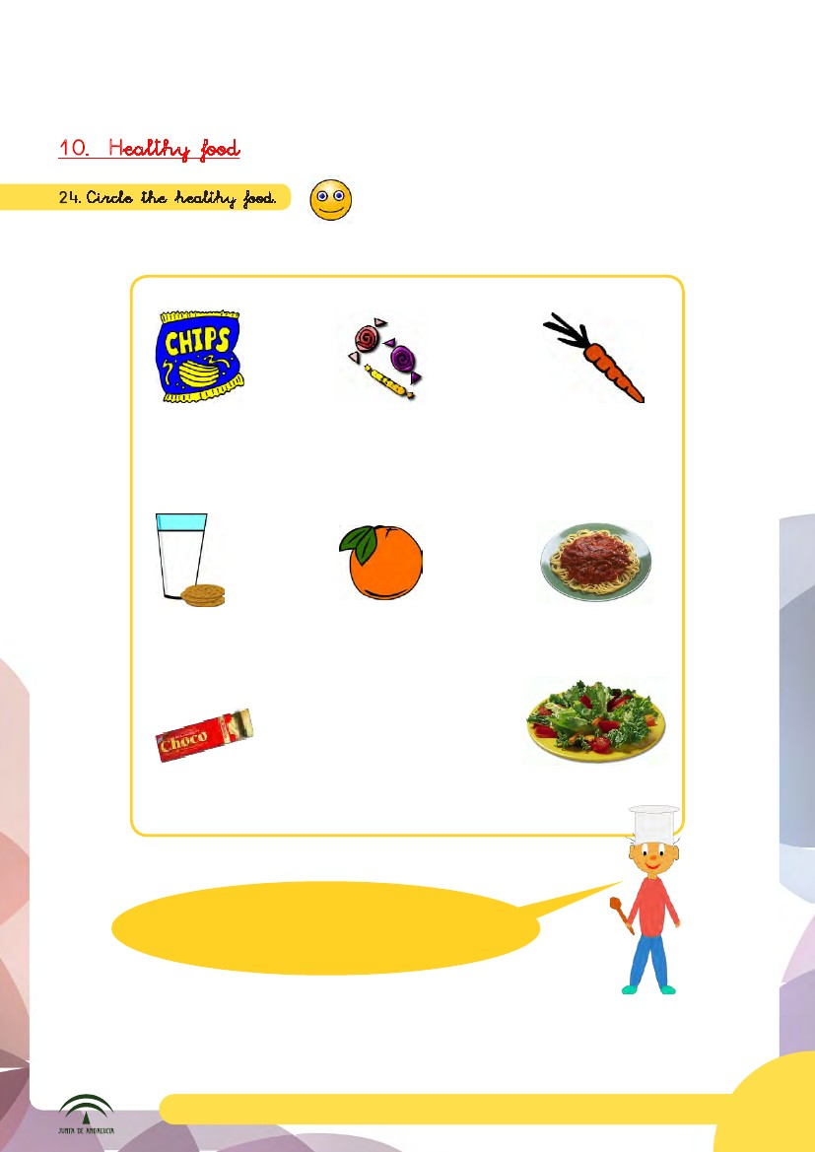
10. Healthy food
24.Circle the healthy food.

chips
sweets
a carrot
milk
and
cookies

an orange

pasta

chocolate

salad

Don’t eat a lot of sweets and chocolate.
They are bad for you!
Material AICLE. 1º de Primaria: Food and Meals
21
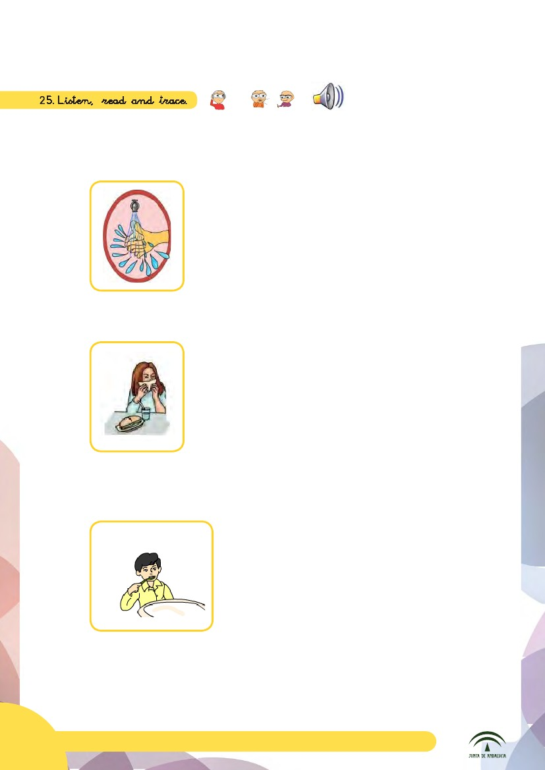
25.Listen, read and trace.

Before you eat you must ...
wash your hands.

While you eat you must ...

After you eat you must ...
use a napkin.

brush your teeth.
22
Material AICLE. 1º de Primaria: Food and Meals
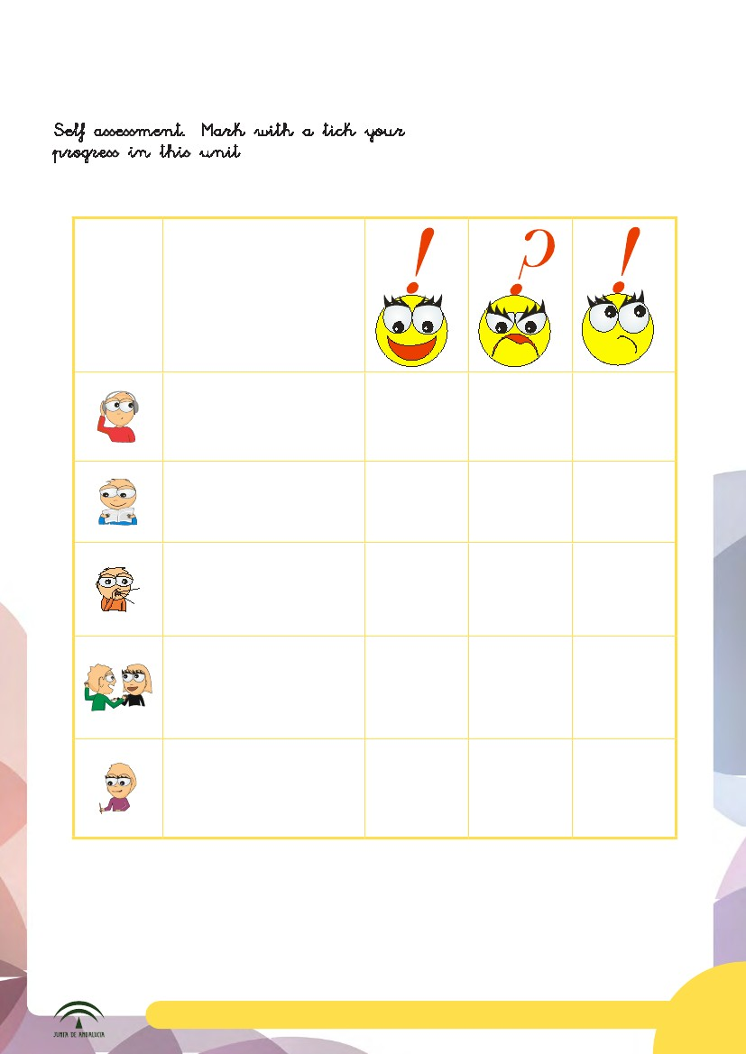
Self assessment. Mark with a tick your
progress in this unit.
I can recognise words
and expressions related
to foods, cutlery and
daily meals.
I can read sentences
about foods, daily meals
and healthy habits.
I can speak about likes
and dislikes, food origins
and where foods go.
I can talk to my
classmates about food
origins and likes and
dislikes.

I can write about food
origins, likes and
dislikes, where foods go,
pieces of cutlery and
healthy habits.
Material AICLE. 1º de Primaria: Food and Meals
23

